A Mini Project Report on

Malicious URL Detection

Submitted in partial fulfillment of the requirements for the award of the degree of

Bachelor of Engineering

in

Computer Engineering
by

Shauryan Singh (19102004)

Aditya Yadav (19102006)

Viraj Jadhav (19102022)

Parag Patil (19102039)

Under the Guidance of

Sofiya Mujawar



Department of Computer Engineering
A.P. Shah Institute of Technology G.B.Road, Kasarvadavli, Thane(W), Mumbai-400615 UNIVERSITY OF MUMBAI

Academic Year 2021-2022

Approval Sheet

This Mini Project Report entitled “Malicious URL Detection” Submitted by “Shauryan Singh” (19102004), “Aditya Yadav” (19102006), “Viraj Jadhav” (19102022), “Parag Patil” (19102039) is approved for the partial fulfillment of the requirement for the award of the degree of Bachelor of Engineering in Computer Engineering from the University of Mumbai.

Prof. Sachin H. Malave Sofiya Mujawar
Head of Department Guide
(Computer Engineering)

Place: A. P. Shah Institute of Technology, Thane Date:

CERTIFICATE

This is to certify that the mini project entitled “Malicious URL Detection” submitted by “Shauryan Singh” (19102004), “Aditya Yadav” (19102006), “Viraj Jadhav” (19102022), “Parag Patil” (19102039) for the partial fulfillment of the requirement for the award of a degree Bachelor of Engineering in Computer Engineering, to the University of Mumbai, is a bonafide work carried out during the academic year 2020-2021.

Sofiya Mujawar
Guide

Prof. Sachin H. Malave Dr. Uttam.Kolekar Head of Department Principal
(Computer Engineering)

External Examiner(s) 1.

2.

Place: A. P. Shah Institute of Technology, Thane
Date:

Declaration

We declare that this written submission represents our ideas in our own words and where others’ ideas or words have been included, we have adequately cited and referenced the original sources. We also declare that We have adhered to all principles of academic honesty and integrity and have not misrepresented or fabricated or falsified any idea/data/fact/source in our submission. We understand that any violation of the above will be cause for disciplinary action by the Institute and can also evoke penal action from the sources which have thus not been properly cited or from whom proper permission has not been taken when needed.

———————————————

(Signature)

———————————————

(Shauryan Singh and 19102004) (Aditya Yadav and 19102006) (Viraj Jadhav and 19102022)
(Parag Patil and 19102039)

Date:

Abstract

A malicious website is a common and serious threat to cybersecurity. Malicious URLs host unsolicited content (spam, phishing, etc.) and lure unsuspecting users to become victims of scams (monetary loss, theft of private information, and malware installation), and cause losses of billions of dollars every year. It is imperative to detect and act on such threats in a timely manner.
Traditionally, this detection is done mostly through the usage of blacklists. However, blacklists cannot be exhaustive and lack the ability to detect newly generated malicious URLs. To improve the generality of malicious URL detectors, machine learning techniques have been explored with increasing attention in recent years
Recently, with the increase in Internet usage, cybersecurity has been a significant challenge for computer systems. Different malicious URLs emit different malicious software and try to capture user information. Signature-based approaches have often been used to detect such websites and detected malicious URLs have been attempted to restrict access by using various security components. This chapter proposes using host-based and lexical features of the associated URLs to better improve the performance of classifiers for detecting malicious websites. Random forest models and gradient boosting classifiers are applied to create a URL classifier using URL string attributes as features. The highest accuracy was achieved by random forest as 98.6%. The results show that being able to identify malicious websites based on URL alone and classify them as spam URLs without relying on on-page content will result in significant resource savings as well as a safe browsing experience for the user.

Contents

- Introduction 1
  - Problem Definition 2
  - Objectives 2
  - Scope 2

- Literature Review 3

- Technology Stack 4
- Benefits and Applications 5
  - Benefits for society 5
  - Applications. 5
- Project Design 6
  - Proposed System 6
  - Level 0 Data Flow Diagram 7
  - Level 1 Data Data Flow Diagram 8-9
- Implementation (Screenshots of output) 10
- Bibliography 11
- Appendices 12

Chapter 1

Introduction

The human-understandable URLs are used to identify billions of websites hosted over the present-day internet. Adversaries who try to get unauthorized access to confidential data may use malicious URLs and present them as legitimate URLs to a naive user. Such URLs that act as a gateway for unsolicited activities are called malicious URLs.
A Malicious URL or a malicious website hosts a variety of unsolicited content in the form of spam, phishing, or other means. Naïve users unknowingly visit such sites and get trapped in them. Such attacks are usually carried out by exploiting vulnerabilities in plugins or inserting malicious code through JavaScript. Phishing and Social Engineering attacks trick the users into revealing private or sensitive information by pretending to be genuine web pages.
Malicious URLs are compromised URLs that are used for cyber-attacks. To avoid information loss the URL identification is the best solution. So the identification of malicious URLs is always a hot area of information security.
Our project proposes using host-based and lexical features of the associated URLs to better improve the performance of classifiers for detecting malicious websites.
The results show that being able to identify malicious websites based on URL alone and classify them as spam URLs without relying on on-page content will result in significant resource savings as well as a safe browsing experience for the user.

1

Problem Statement

Developing a machine learning model capable of detecting malicious URLs which will protect the privacy and integrity of sensitive credentials of the users and warn the users about its danger in the form of an interface or a service.

Objectives

- To Detect and Notify the user about the URL being malicious or benign.
- To protect users’ sensitive data in case of a phishing URL attack.
- Our ultimate goal is to contribute to the creation of a real-time malware classifier to block out malicious URLs.

Scope

- In this model, we further aim to improve the accuracy of our classifier so that our model can more accurately classify URLs and eliminate even a minute chance of any breach.
- The functionality of adding this model as a chrome extension will make it a lot more responsive and increase its usability.

2

Chapter 2

Literature Review
Paper Name | Published Year | Features
Malicious URL Detection based on Machine Learning | 2020 | - Method for malicious URL detection using machine learning is presented  - URL Attribute Extraction and Selection
Malicious URL Detection using Machine Learning: A Survey | 2019 | - Host-based Features  - Lexical Features  - Content-based Features  - Popularity Features

Blacklisting or Heuristic Approaches.
Blacklisting approaches are a common and classical technique for detecting malicious URLs, which often maintain a list of URLs that are known to be malicious. Whenever a new URL is visited, a database lookup is performed. If the URL is present in the blacklist, it is considered to be malicious and then a warning will be generated; else it is assumed to be benign.

Machine Learning Approaches.
These approaches try to analyze the information of a URL and its corresponding websites or webpages, by extracting good feature representations of URLs, and training a prediction model on training data of both malicious and benign URLs.

Lexical Features
Lexical features are features obtained from the properties of the URL name (or the URL string). The motivation is that based on how the URL "looks" it should be possible to identify the malicious nature of a URL. For example, many obfuscation methods try to "look" like benign URLs by mimicking their names and adding a minor variation to it.
Host-based Features
Host-based features are obtained from the host-name properties of the URL. They allow us to know the location, identity, and the management style and properties of malicious hosts.
Popularity Features
Some other features used were designed as heuristics to measure the popularity of the URL. One of the earliest approaches to applying statistical techniques to detect malicious URLs aimed at probabilistically identifying the importance of specific hand-designed features. These include Page-based features (Page rank, quality, etc.)
3

Chapter 3

Technology Stack

- Python: Python is a computer programming language often used to build websites and software, automate tasks, and conduct data analysis. Python is a general-purpose language, meaning it can be used to create a variety of different programs and isn’t specialized for any specific problems. This versatility, along with its beginner-friendliness, has made it one of the most-used programming languages today.

- Sklearn: Scikit-learn (Sklearn) is the most useful and robust library for machine learning in Python. It provides a selection of efficient tools for machine learning and statistical modeling including classification, regression, clustering, and dimensionality reduction via a consistent interface in Python.

- Pandas: Pandas is an open-source, licensed Python library providing high-performance, easy-to-use data structures and data analysis tools for the Python programming language.

- NumPy: It stands for Numerical Python, it is a library consisting of multidimensional array objects and a collection of routines for processing those arrays. It offers comprehensive mathematical functions, random number generators, linear algebra routines, etc.

4
Chapter 4
Benefits and Applications

- Malicious URL detection using machine learning can have immense real-world applications. However, it is nontrivial to make it work in practice. Several researchers have proposed architectures for building end-to-end malicious URL Detection systems and deployed them for real-world utilities.
- Malicious URL detectors have many real-time applications. One of the main advantages of using these URL detectors is to protect your system from phishing and various cyber-attacks. This detection using machine learning is more useful for people from non-technical backgrounds who find it hard to differentiate between those scams and legitimate websites.

5

Chapter 5 Project Design

5.1 Proposed System

- In this project, we have selected a dataset from Kaggle which contains a finite set of categorical data named "Malicious Url Dataset.csv".

- Then we did data pre-processing in which we extracted the year from the Date Columns and also encoded the categorical data with the help of one hot encoder.

- After the implementation of data pre-processing, we split the data into training and testing sets and also applied feature scaling in this process.

- At last, we used KNN Model to train our machine and checked the accuracy of our model from the derived confusion matrix.

6

5.2 Level 0 DFD

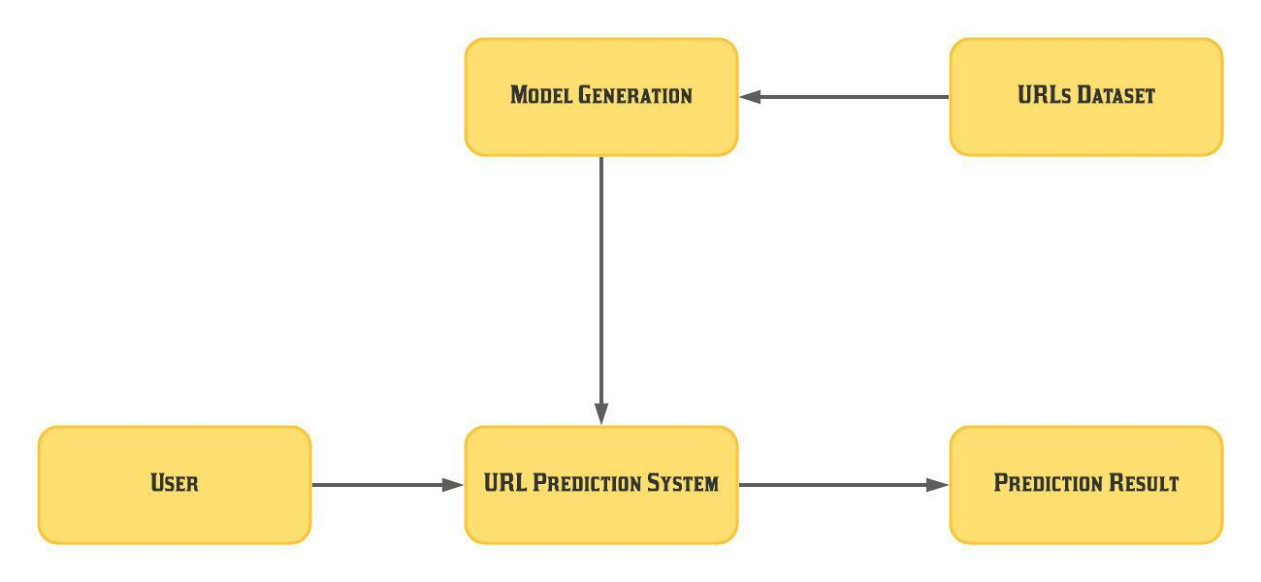

7

5.3 Level 1 DFD

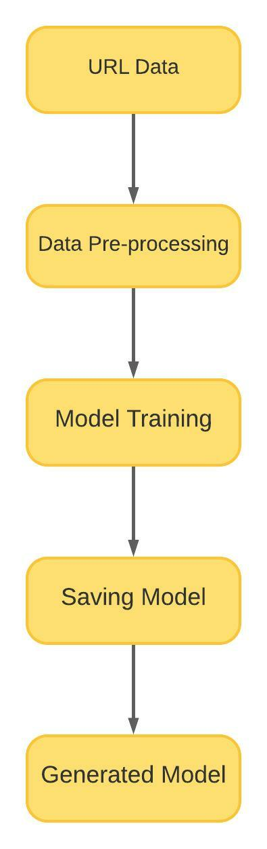

8

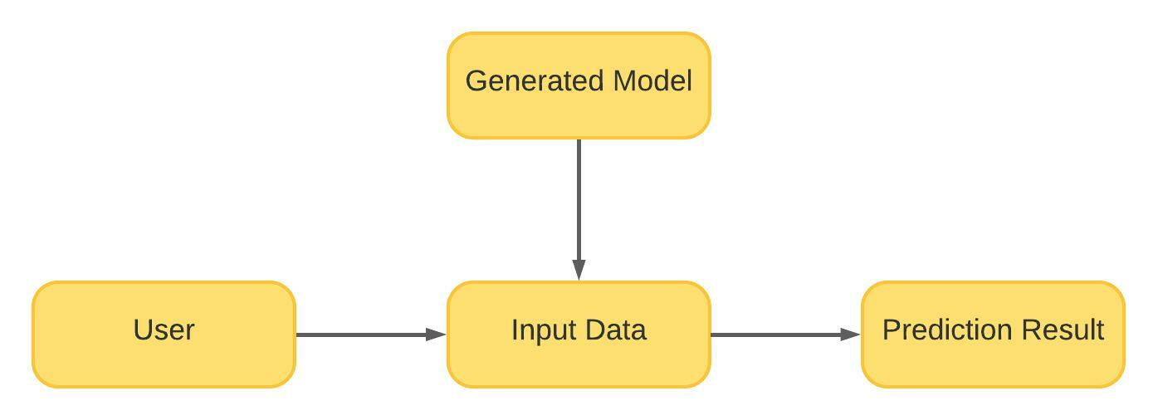

9

Chapter 6

Implementation – screenshots of outputs

- Confusion Matrix with Accuracy of our model
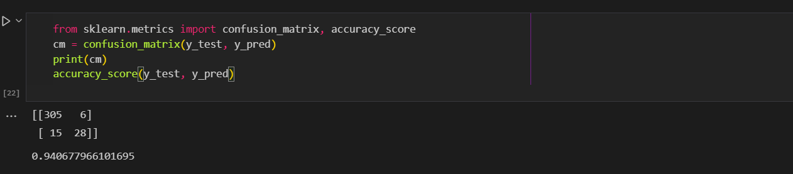
- Predicting using model
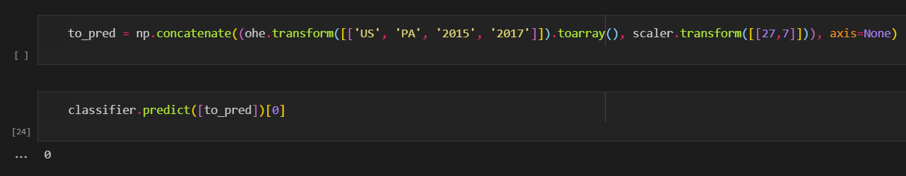

10

Chapter 7

Bibliography

- Arya Babu,“Literature Survey on Malicious URL Identification”, http://ijniet.org/wp-content/uploads/2015/07/2.pdf, July 2015.
- F. Vanhoenshoven, G. Nápoles, R. Falcon, K. Vanhoof and M. Köppen, "Detecting malicious URLs using machine learning techniques," 2016 IEEE Symposium Series on Computational Intelligence (SSCI), 2016, pp. 1-8, doi: 10.1109/SSCI.2016.7850079.
- https://www.kaggle.com/xwolf12/malicious-and-benign-websites
- https://medium.com/@ismaelbouarfa/malicious-url-detection-with-machine-learning-d57890443dec
- https://towardsdatascience.com/phishing-domain-detection-with-ml-5be9c99293e5
- Malicious URL Detection using Machine Learning: A Survey
- Malicious URL Detection based on Machine Learning

11

Chapter 8

Appendices

Installation of Modules:

The technology stack used in this project is Python (programming language), VS Code (IDE), Scikit Learn, pandas, and NumPy as modules. There are some dependencies, to run this code, your system would need modules, and here’s how you can install them and run this project.

Steps:

- Download the latest version of the Python programming language.
- Check if “pip” is also installed simultaneously, if not installed refer to this for PIP Installation.
- In VS Code download Jupyter Extension for the .ipynb file.
- Open the python folder in VS Code.
- In VS Code Terminal run the following commands to install the modules needed in this project.
-pip install numpy
-pip install pandas
-pip install sklearn
- If you have properly installed everything on your machine, then you can seamlessly run the code.

For any other guidance or support, check out these official websites of the libraries and other software we used to develop this project.

- Python
- Pip
- Numpy
- Pandas
- Scikit Learn

12

Acknowledgment

We have great pleasure in presenting the mini project report on Malicious URL Detection. We take this opportunity to express our sincere thanks towards our guide Sofiya Mujawar Department of Computer Engineering, APSIT Thane for providing the technical guidelines and suggestions regarding the line of work. We would like to express our gratitude for his constant encouragement, support, and guidance throughout the development of the project.
We thank Prof. Sachin Malave Head of Department, Computer Engineering, APSIT for his encouragement during the progress meeting and for providing guidelines to write this report.
We also thank the entire staff of APSIT for their invaluable help rendered during the course of this work. We wish to express our deep gratitude to all our colleagues of APSIT for their encouragement.

Shauryan Singh (19102004)

Aditya Yadav (19102006)

Viraj Jadhav (19102022)

Parag Patil (19102039)

13

